**EXPENSE TRACKER**

**A PROJECT REPORT**

***Submitted by***

**HEMANT SHARMA (2311981239)**

**DEEPANSHU (2311981177)**

**MANISH KUMAR (2311981319)**

**HARSHWARDHAN SINGH (2311981237)**

***in partial fulfillment for the award of the degree***

***of***

**BACHELOR OF ENGINEERING**

***in***

**COMPUTER SCIENCE AND ENGINEERING**

**CHITKARA UNIVERSITY HIMACHAL PRADESH BADDI -174103**

APRIL 2024

## BONAFIDE CERTIFICATE

Certified that this project report **“EXPENSE TRACKER”** is the bonafide work of “**Hemant Sharma, Manish Kumar, Deepanshu, Harshwardhan”** who carried out the project work under my supervision. Certified further that to the best of my knowledge the work reported herein does not form part of any other thesis or dissertation on the basis of which a degree or award was conferred on an earlier occasion on this or any other candidate.

_________________

**Signature of Supervisor**

### 

### Dr. Dileep Kumar Sharma

### Associate Professor

### Chitkara University, Himachal Pradesh

**Abstract**

This project report presents a comprehensive overview of the development and functionality of an Expense Tracker application, designed to assist users in managing their personal finances more effectively. The application aims to provide a user-friendly platform that allows individuals to monitor their spending, categorize expenses, and visualize their financial habits over time. By leveraging technology to simplify the task of financial management, the Expense Tracker endeavors to encourage a more conscientious approach to spending and saving.

Developed using modern software engineering principles, the Expense Tracker application features a clean and intuitive interface, with functionalities that cater to the needs of a diverse user base. Users can input their daily expenses, classify them into customizable categories (such as food, transportation, and utilities), and set budget limits for each category to prevent overspending. The application also includes tools for generating detailed reports and analytics, offering insights into spending patterns and helping users identify potential areas for financial improvement.

One of the key highlights of the project is its focus on security and privacy, ensuring that users' financial data is protected through state-of-the-art encryption methods. Additionally, the application supports multi-platform accessibility, meaning it can be used across various devices, further enhancing user convenience.

The development process outlined in this report follows a structured approach, starting from requirement analysis, through design and implementation, to testing and deployment. Challenges encountered during the project, such as ensuring cross-platform compatibility and designing an effective user experience, are discussed in detail. The report also explores potential future enhancements, including the integration of artificial intelligence algorithms for personalized financial advice and the expansion of the application to support group or family budgeting.

In conclusion, the Expense Tracker project represents a significant step forward in personal financial management tools. By combining advanced technological solutions with a deep understanding of user needs, the application not only simplifies the task of tracking expenses but also empowers users to make better financial decisions. This report serves as a detailed

documentation of the project's objectives, development process, and ultimate realization, offering insights that could inform future endeavors in the field of financial technology.

**Table of Contents**

Chapter 1: Introduction

1.1 General...........................................................................................................................09

1.1.1 Overview of Personal Finance Management...............................................................09

1.1.2 Importance of Tracking Expenses...............................................................................09

1.1.3 Challenges Faced in Managing Personal Finances......................................................09

1.1.4 Introduction to Expense Tracker Application..............................................................10

1.1.5 Purpose and Objectives of the Application..................................................................10

1.1.6 Key Features and Functionalities................................................................................10-11

1.2 Problem Formulation.....................................................................................................1

1.2.1 Inadequacies of Traditional Expense Tracking Methods.............................................12

1.2.2 Identification of User Needs......................................................................................12

1.2.2.1 Difficulty in tracking expenses.................................................................................12

1.2.2.2 Lack of awareness about budgeting..........................................................................12

1.2.2.3 Need for accessible tools..........................................................................................12

1.2.3 Prioritized Features and Functionalities......................................................................12-13

1.2.1 General........................................................................................................................13

1.2.1.1 Overview of Current Financial Landscape...............................................................13

1.2.1.2 Trends in personal finance management..................................................................13-14

1.2.1.3 Role of technology in facilitating financial tracking.................................................14

1.2.2 User Requirements Analysis.......................................................................................14-16

1.2.2.1 Methodologies for Gathering User Requirements...................................................14-16

1.2.2.2 Summary of User Feedback.....................................................................................14

1.2.2.2.1 Simplicity and Ease of Use....................................................................................15

1.2.2.2.2 Flexibility..............................................................................................................15

1.2.2.2.3 Real-Time Tracking and Alerts.............................................................................15

1.2.2.2.4 Insights and Analysis.............................................................................................15

1.2.2.3 Importance of User-Centric Design.........................................................................16

1.2.2.2 User Interface Design...............................................................................................18

Fig 1.1..................................................................................................................................18

1.2.2.2.1 Design Considerations for Expense Tracker UI.....................................................18

1.2.2.3 Technology Stack Selection.....................................................................................19

1.2.2.3.1 Evaluation of Technology Options........................................................................19

1.2.2.3.2 Rationale for Technology Choices........................................................................19

1.3 Proposed Solution / Methodology..................................................................................19

1.3.1 Overview of Expense Tracker Solution.......................................................................20

1.3.2 Description of the application's core functionalities....................................................20

1.3.3 Methodology for Development and Implementation..................................................20

1.4 Results...........................................................................................................................21-22

1.4.1 Implementation Progress and Achievements..............................................................21

1.4.2 Milestones reached during development.....................................................................21

1.4.3 Challenges encountered and solutions devised........................................................... 21

1.5 Conclusion.....................................................................................................................21-22

1.5.1 Summary of Introduction Chapter...............................................................................21

1.5.2 Transition to Subsequent Chapters..............................................................................22

1.5.3 Anticipation of Project Outcomes............................................................................... 22

Chapter 2: Literature Review

2.1 General..................................................... .....................................................................23-24

2.1.1 Introduction to the Literature Review..........................................................................23

2.1.2 Definition and Significance of a Literature Review.....................................................23

2.1.3 Purpose of Reviewing Existing Literature...................................................................23

2.1.4 Overview of Personal Finance Management Literature..............................................24

2.2 Detailed Analysis of Existing Literature........................................................................24

2.2.1 Review of Existing Expense Tracking Solutions.........................................................24

2.2.2 Comparative Analysis of Expense Tracking Methods.................................................24

2.3 Summary and Critique...................................................................................................25

2.3.1 Summary of Reviewed Literature...............................................................................25

2.3.2 Critique of Existing Research......................................................................................25

2.4 Conclusion.....................................................................................................................25-26

2.4.1 Recapitulation of Literature Review Chapter..............................................................25

2.4.2 Implications for the Expense Tracker Project..............................................................26

2.4.3 Transition to Subsequent Chapters..............................................................................26

Chapter 3: Technical Aspects

3.1 Technology Stack..........................................................................................................27

3.1.1. Frontend.....................................................................................................................27

3.1.2. Backend.....................................................................................................................27

3.1.3. Authentication and Authorization..............................................................................27

3.2 System Architecture.....................................................................................................27-28

3.2.1. Client-Side.................................................................................................................27

3.2.2. Server-Side.................................................................................................................28

3.2.3. Database.....................................................................................................................28

3.3 Data Management.........................................................................................................28-29

3.3.1.Data Modeling............................................................................................................28

3.3.2.Data Storage................................................................................................................28

3.3.3.Data Access.................................................................................................................28

3.3.4.Data Security..............................................................................................................29

3.4 Security Measures.........................................................................................................29

3.4.1Authentication.............................................................................................................29

3.4.2.Authorization.............................................................................................................29

3.4.3.Data Encryption..........................................................................................................29

3.4.4.Security Auditing........................................................................................................29

**Chapter 4: Coding**

Fig 4.1 Back-end..................................................................................................................30

Fig 4.2 HTML(Main Site) ...................................................................................................31

Fig 4.3CSS(MainSite) .........................................................................................................32

Fig 4.4 HTML(Login Page) ................................................................................................33

Fig 4.5 CSS(Login Page) .....................................................................................................34

**Chapter 5: Results and Evaluation**

5.1. Implementation Progress and Achievements: ...............................................................35

5.2. Technical Evaluation: ...................................................................................................35

5.3. Iterative Improvements: ...............................................................................................36

5.4. Evaluation of Project Outcomes: ..................................................................................36

5.5. Future Directions and Recommendations: ....................................................................37

5.6. Conclusion: ..................................................................................................................37

**Chapter 6: Conclusion**

6.1. Summary of Project Objectives: ...................................................................................38

6.2. Recap of Project Process: .............................................................................................38

6.3. Evaluation of Project Outcomes: ..................................................................................38-39

6.4. Contributions to Personal Finance Management: .........................................................39

6.5. Lessons Learned and Recommendations: .....................................................................39

6.6. Conclusion: ..................................................................................................................39

**Refrences**..............................................................................................................,.........40-41

**Table of Figures**

1.1 Features………...............................................................................................................11

1.2 APP Home Page...............................................................................................................18

5.1 Web Home Page...............................................................................................................36

5.2 Welcome Page..................................................................................................................37

5.3 Login Page.......................................................................................................................37

**Chapter 1: Introduction**

1.1 General

Overview of Personal Finance Management:

Personal finance management is a multifaceted discipline that encompasses a wide range of financial activities and decisions. These include budgeting, saving, investing, debt management, retirement planning, and more. Each aspect of personal finance requires careful consideration and strategic planning to achieve financial goals and maintain financial well-being. Understanding personal finance is not only important for individuals but also for society as a whole, as it contributes to economic stability and prosperity.

Importance of Tracking Expenses:

Tracking expenses is a foundational practice in personal finance management. It involves monitoring and categorizing all expenditures, whether big or small, to gain a comprehensive understanding of where money is being spent. By tracking expenses, individuals can identify spending patterns, recognize areas of overspending, and make informed decisions about budgeting and saving. Moreover, tracking expenses promotes accountability and discipline in financial behavior, leading to better financial outcomes in the long run.

Challenges Faced in Managing Personal Finances:

Despite the importance of personal finance management, individuals often face numerous challenges in effectively managing their finances. These challenges can include limited financial literacy, lack of awareness about financial products and services, difficulty in adhering to budgeting goals, and unexpected financial emergencies. For college students, in particular, managing finances can be especially challenging due to factors such as limited income, student loans, and the pressure to balance academic responsibilities with social activities.

Introduction to Expense Tracker Application:

In response to the challenges faced by users in managing their finances, the Expense Tracker application offers a user-friendly solution for tracking expenses and managing budgets. The application leverages technology to provide college students with a convenient and accessible tool for monitoring their spending habits, setting financial goals, and making informed financial decisions. By empowering users to take control of their finances, the Expense Tracker application aims to promote financial literacy and responsible financial behavior among college students.

Purpose and Objectives of the Application:

The primary purpose of the Expense Tracker application is to provide college students with a practical tool for managing their finances effectively. The objectives of the application include:

1. Simplifying the process of expense tracking and budgeting:

Expense tracking and budgeting can be daunting tasks for college students, especially those who are new to managing their finances. The Expense Tracker application aims to simplify these processes by providing a user-friendly and intuitive interface. Through features such as easy expense input, automated categorization, and customizable budgeting tools, users can quickly and effortlessly track their expenses and adhere to budgeting goals. By streamlining these tasks, the application reduces the barriers to effective financial management and empowers users to take control of their finances.

1. Providing insights into spending habits and patterns:

Understanding spending habits and patterns is essential for making informed financial decisions and identifying areas for improvement. The Expense Tracker application offers insights and analysis tools that enable users to gain a comprehensive understanding of their spending behavior. Through detailed reports, visualizations, and trend analysis, users can identify spending trends, recognize patterns, and pinpoint areas of overspending. These insights empower users to make adjustments to their spending habits, set realistic budgeting goals, and achieve greater financial stability over time.

1. Helping users set and achieve financial goals:

Setting and achieving financial goals is key to long-term financial success. The Expense Tracker application facilitates goal setting and tracking by allowing users to define personalized financial objectives. Whether it's saving for tuition, paying off student loans, or building an emergency fund, users can set specific goals within the application. The application provides progress tracking features, reminders, and notifications to keep users motivated and accountable towards reaching their financial milestones. By providing a clear roadmap and tools for goal management, the application empowers users to take meaningful steps towards their financial aspirations.

1. Promoting financial literacy and responsible spending habits among college students:

Financial literacy is crucial for individuals to make informed financial decisions and achieve financial well-being. The Expense Tracker application goes beyond simple expense tracking by incorporating educational resources and tips on financial management. Through interactive tutorials, articles, and budgeting guides, the application educates users about essential financial concepts, such as budgeting, saving, investing, and debt management. By promoting financial literacy and instilling responsible spending habits, the application equips college students with the knowledge and skills they need to navigate their financial futures confidently.

In summary, the Expense Tracker application aims to simplify expense tracking and budgeting, provide insights into spending habits, facilitate goal setting and achievement, and promote financial literacy and responsible spending habits among college students. By addressing these objectives, the application empowers users to take control of their finances and build a solid foundation for their financial futures.

Key Features and Functionalities:

The Expense Tracker application offers a range of features and functionalities designed to meet the specific needs of college students. These include:

1. Expense tracking:

Users can easily record and categorize their expenses, either manually or through automated imports from bank accounts and credit cards.

1. Budgeting tools:

The application allows users to set monthly or weekly budgets for different expense categories, with customizable alerts and notifications to help users stay on track.

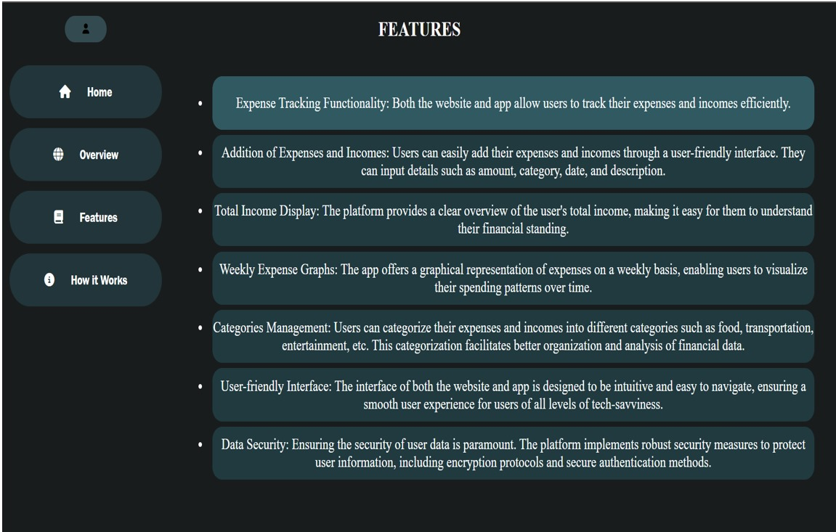

Fig 1.1 (Features)

1. Financial insights:

Users can access detailed reports and visualizations to analyze their spending patterns, identify areas of overspending, and track progress towards financial goals.

1. Goal setting:

The application enables users to set short-term and long-term financial goals, such as saving for tuition, paying off student loans, or building an emergency fund.

1. User-friendly interface:

The application features a clean and intuitive interface that is easy to navigate, with clear menus, icons, and labels to guide users through the various features and functionalities.

1.2 Problem Formulation

Inadequacies of Traditional Expense Tracking Methods:

Traditional methods of expense tracking, such as pen and paper or Excel spreadsheets, are often cumbersome, time-consuming, and prone to errors. These manual methods require individuals to manually input and categorize every expense, which can be tedious and easily overlooked. Moreover, manual methods lack the convenience and accessibility of digital solutions, making it difficult for individuals to track their expenses in real-time and gain timely insights into their spending habits.

Identification of User Needs:

* 1. Difficulty in tracking expenses:

Many people struggle to keep track of their expenses, leading to overspending and financial stress.

* 1. Lack of awareness about budgeting:

students & interns often lack the knowledge and skills needed to create and stick to a budget, resulting in poor financial habits and financial instability.

* 1. Need for accessible tools:

Normally it require accessible and user-friendly tools to assist people in managing their finances, as they often lack the time, resources, and expertise to effectively manage their finances on their own

Prioritized Features and Functionalities:

The following features and functionalities were prioritized for the Expense Tracker application:

* 1. Simple and intuitive user interface:

A clean and user-friendly interface that is easy to navigate, with clear labels and instructions.

* 1. Customizable budgeting tools:

The ability for users to set personalized budgets for different expense categories and customize alerts and notifications.

* 1. Real-time expense tracking:

Automatic categorization of expenses and real-time updates to reflect transactions, with the option for manual input.

* 1. Insights and analysis:

Detailed reports, visualizations, and recommendations to help users analyze their spending habits and identify areas for improvement.

* 1. Goal setting and tracking:

Tools for users to set financial goals, track progress, and receive reminders to stay on track.

1.2.1 General

Overview of Current Financial Landscape:

The current financial landscape is characterized by rapid technological advancements and changing consumer preferences. With the rise of smartphones, mobile banking apps, and digital payment platforms, individuals now have access to a wide range of tools and resources to help them manage their finances more effectively. Moreover, the COVID-19 pandemic has accelerated the adoption of digital financial services, as more people turn to online and mobile banking for convenience and safety.

Trends in personal finance management:

Several key trends are shaping the field of personal finance management, including:

* 1. Increased use of technology:

Technology plays an increasingly important role in personal finance management, with the proliferation of mobile apps, budgeting tools, and robo-advisors.

* 1. Shift towards cashless payments:

Cashless payments, such as credit cards, debit cards, and mobile wallets, are becoming increasingly popular due to their convenience and security.

* 1. Rise of alternative financial services:

Alternative financial services, such as peer-to-peer lending, robo-advisors, and cryptocurrency, are gaining traction as people seek alternative ways to manage their finances and invest their money.

* 1. Focus on financial education:

There is a growing emphasis on financial education and literacy, with schools, employers, and financial institutions offering resources and programs to help individuals improve their financial knowledge and skills.

Role of technology in facilitating financial tracking:

Technology plays a crucial role in facilitating financial tracking and management by providing individuals with access to a wide range of tools and resources to help them monitor their finances, set financial goals, and make informed financial decisions. These tools include budgeting apps, expense tracking software, investment platforms, and financial management dashboards, which enable users to track their expenses, analyze their spending habits, and manage their finances more effectively.

1.2.2 User Requirements Analysis

Methodologies for Gathering User Requirements:

Various methodologies were used to gather user requirements for the Expense Tracker application, including surveys, interviews, focus groups, and usability testing. These methodologies helped identify user needs, preferences, and pain points, as well as gather feedback on potential features and functionalities for the application.

The summary of user feedback for the Expense Tracker application reveals several key themes and preferences expressed by users:

1. Simplicity and Ease of Use:

Users emphasized the importance of a clean and intuitive interface that is easy to navigate and understand. This is particularly crucial for users with limited financial knowledge and experience, who may find complex interfaces overwhelming. A straightforward user experience ensures that users can quickly and effortlessly manage their finances without encountering obstacles or confusion.

1. Flexibility:

Personalization options enable users to adapt the application to their unique financial situations, preferences, and goals. By providing flexibility in budgeting, categorization, and notification settings, the application can accommodate diverse user preferences and requirements.

1. Real-Time Tracking and Alerts:

Users indicated a preference for real-time expense tracking and notifications to help them stay on top of their finances and avoid overspending. Timely updates and alerts ensure that users are continuously aware of their spending habits and can make informed decisions in real-time. By providing instant feedback and reminders, the application promotes accountability and encourages responsible financial behavior.

1. Insights and Analysis:

Users expressed interest in features that provide insights and analysis of their spending habits. Detailed reports, visualizations, and recommendations empower users to analyze their financial data, identify trends, and make informed decisions about budgeting and saving. By offering valuable insights into spending patterns and behaviors, the application

facilitates self-reflection and enables users to take proactive steps towards financial improvement.

Overall, the user feedback highlights the importance of designing the Expense Tracker application with simplicity, customizability, real-time tracking, and insightful analysis in mind. By prioritizing these user preferences, the application can offer a user-friendly and effective solution for managing finances, empowering users to achieve their financial goals and build a secure financial future

1.2.2.1 General

Importance of User-Centric Design:

User-centric design principles were central to the development process of the Expense Tracker application. By prioritizing the needs and preferences of users, the application was designed to be intuitive, accessible, and effective in addressing the challenges faced by college students in managing their finances.

The design of the Expense Tracker application was guided by principles of user experience (UX) design, including:

I. Enhanced Usability: Devoting meticulous attention to detail to ensure that the application boasts an intuitive interface, facilitating quick and efficient user interaction, while also demonstrating robust error tolerance to accommodate users of all proficiency levels.

II. Inclusive Accessibility: Championing inclusivity by meticulously crafting the application to cater to users with diverse abilities and requirements, including those with disabilities. This involves implementing features and design choices that enhance accessibility, ensuring a seamless experience for all users, regardless of their individual needs.

III. Unwavering Consistency: Upholding steadfast consistency across all aspects of the application's design, including visual elements, interactive features, and terminologies. By maintaining uniformity throughout the application, users can navigate with confidence, bolstering comprehension and minimizing confusion.

IV. Iterative Design Excellence: Adopting a systematic approach to design refinement by integrating comprehensive feedback from teammates across multiple iterative design cycles. This iterative process allows for continual improvement of the user experience, enabling the team to identify and address usability challenges effectively while refining the application's overall design.

Incorporating Teammate Opinion into Application Design:

Everyone’s opinion played a central role in shaping the design of the Expense Tracker application. Through usability testing, preferences, pain points, suggestions were gathered and incorporated into the design process. This iterative approach ensured that the application met the needs and expectations of its target users.

1.2.2.2 User Interface Design

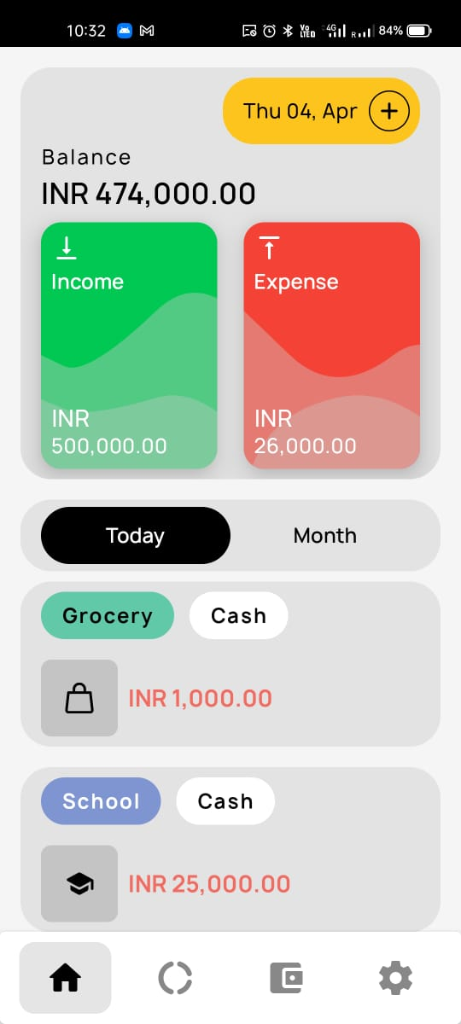

Design Considerations for Expense Tracker UI:

Several design considerations were taken into account in the development of the Expense Tracker user interface, including:

* 1. Simplicity:

Prioritizing simplicity and clarity in design to minimize cognitive load and make the application easy to use for users of all levels of financial literacy.

* 1. Intuitiveness:

Ensuring that the interface is intuitive and predictable, with familiar design patterns and consistent navigation elements.

* 1. Accessibility:

Designing the interface to be accessible to users with diverse needs, including those with visual or motor impairments.

Fig 1.2 (APP Home Page)

* 1. Visual hierarchy: Using visual hierarchy to prioritize important information & guide users' attention to key features/ functionalities.
  2. Mobile responsiveness: Optimizing the interface for mobile devices to accommodate users who primarily access the application on smartphones or tablets.

1.2.2 Technology Stack Selection

Evaluation of Technology Options

Various technology options were evaluated for the development of the Expense Tracker application, including programming languages, frameworks, databases, and deployment options. Considerations such as scalability, security, developer familiarity, and ecosystem support were taken into account during the evaluation process.

Programming languages, frameworks, and libraries:

The technological foundation of the Expense Tracker application encompasses the utilization of Kotlin as the primary programming language, imbuing it with robust functionality and flexibility. On the other hand, the website's architecture harnesses the power of JavaScript and HTML, synergistically weaving together dynamic interactivity and seamless user experience. This strategic selection of programming languages underscores our commitment to leveraging cutting-edge technologies to deliver unparalleled performance and user satisfaction across both platforms.

Rationale for Technology Choices:

The technology stack chosen for the Expense Tracker application was selected based on several factors, including compatibility with project requirements, ease of development, community support, and scalability. By leveraging appropriate technologies, the application can deliver optimal performance, security, and user experience.

Considerations for scalability, security, and developer familiarity:

Scalability, security, and developer familiarity were key considerations in selecting the technology stack for the Expense Tracker application. Technologies were chosen based on their ability to scale to accommodate a growing user base, their robust security features to protect user data, and their familiarity among the development team to ensure efficient development and maintenance of the application.

1.3 Proposed Solution / Methodology

Overview of Expense Tracker Solution:

The Expense Tracker application provides the user with a user-friendly platform for managing their finances effectively. By offering features such as expense tracking, budget setting, and financial insights, the application aims to promote financial literacy and empower users to make informed financial decisions.

Description of the application's core functionalities:

I. Expense tracking:

Expense tracking is the foundation of effective financial management. The Expense Tracker application offers users the ability to meticulously record and categorize their expenses. Users can manually input their expenses into the application, providing details such as the date, amount, and category of each expenditure. Additionally, the application supports automated imports from bank accounts and credit cards, streamlining the process of expense tracking. By accurately categorizing expenses, users can gain insights into their spending habits, identify areas of overspending, and make informed decisions about budgeting and saving.

II. Budget setting:

Budgeting is a crucial aspect of financial planning, helping individuals allocate their resources effectively and achieve their financial goals. The Expense Tracker application empowers users to set personalized budgets for different expense categories, such as groceries, dining out, entertainment, and transportation. Users can define budget limits for each category based on their financial priorities and constraints. The application provides alerts and notifications to keep users informed about their budget status and warn them when they are approaching or exceeding their budget limits. By setting and monitoring budgets, users can maintain control over their spending and work towards achieving their financial objectives.

III. Financial insights:

Understanding spending patterns and behaviors is essential for making informed financial decisions. The Expense Tracker application offers users access to detailed reports, visualizations, and recommendations to gain valuable insights into their financial habits. Users can generate reports that summarize their spending by category, timeframe, or merchant, allowing them to identify trends and patterns in their expenses. Visualizations such as charts, graphs, and pie diagrams provide users with a clear and intuitive representation of their financial data. Additionally, the application offers personalized recommendations and suggestions to help users optimize their spending, save money, and improve their overall financial health.

IV. Goal setting and tracking:

Setting and tracking financial goals is key to achieving financial success. The Expense Tracker application provides users with tools to define, track, and manage their financial objectives. Users can set specific goals, such as saving for a vacation, paying off debt, or building an emergency fund, within the application. The application allows users to track their progress towards these goals, providing visual indicators and progress bars to monitor their achievements. Users can also receive reminders and notifications to stay focused and motivated on their financial goals. By setting tangible objectives and monitoring their progress, users can

take proactive steps towards improving their financial well-being and achieving long-term financial stability.

In summary, the Expense Tracker application enables users to track their expenses accurately, set personalized budgets, gain valuable financial insights, and manage their financial goals effectively. By addressing these objectives, the application empowers users to take control of their finances, make informed decisions, and work towards achieving their financial aspirations.

Methodology for Development and Implementation:

The development and implementation strategy employed for the Expense Tracker application embraced agile methodologies, fostering an iterative approach encompassing various stages such as design conceptualization, development, rigorous testing, and deployment. This meticulously structured methodology facilitated ongoing feedback loops and seamless collaboration among developers, designers, and end-users, thereby cultivating an environment conducive to the refinement and enhancement of the application's features. By prioritizing adaptability and responsiveness, this approach ensured that the final product resonated with user needs and preferences, ultimately culminating in a more robust and user-centric application ecosystem.

1.4 Results

Implementation Progress and Achievements:

Milestones were achieved during the development of the Expense Tracker application, including the implementation of key features and functionalities. Challenges encountered during the development process were addressed through innovative solutions and collaboration among team members.

Milestones reached during development:

Certainly! Let's explore each aspect of the Expense Tracker application development process in more detail:

* 1. Design and development of the user interface:

Designing and developing the user interface (UI) of the Expense Tracker application is crucial for creating a seamless and intuitive user experience. This involves several steps, including:

i. Comprehensive User Research: Conducting in-depth analyses to grasp the nuanced needs, preferences, and behavioral patterns of the target user demographic. This involves employing a multifaceted approach, including user research methodologies, surveys, and insightful interviews, to glean valuable insights that inform the application's development trajectory.

ii. Elaborate Wireframing: Embarking on the process of crafting detailed wireframes or low-fidelity prototypes to meticulously delineate the application's layout, structure, and navigation pathways. By intricately mapping out these foundational elements, the wireframes serve as a blueprint that guides subsequent design and development endeavors.

iii. Sophisticated Visual Design: Engaging in the meticulous development of the application's visual components, encompassing aspects such as thoughtfully curated color schemes, typography selections, bespoke icons, and visually captivating graphics. This concerted effort aims to cultivate a harmonious and visually immersive interface that resonates with users and reinforces brand identity.

iv. Iterative Interactive Prototyping: Iteratively constructing interactive prototypes that emulate the user experience and simulate the intricate flow and interactions within the application. These prototypes serve as invaluable tools for conducting rigorous usability testing and facilitating iterative refinement, ensuring that the final product aligns seamlessly with user expectations and usability standards.

v. Robust Responsive Design: Implementing a robust responsive design approach to ensure that the application's user interface dynamically adapts and optimally renders across an array of

devices and screen sizes. By prioritizing adaptability and consistency, regardless of the user's chosen platform or device, this approach fosters an uninterrupted and cohesive user experience.

By focusing on user-centered design principles and best practices, the UI of the Expense Tracker application aims to be intuitive, user-friendly, and aesthetically pleasing, enhancing the overall user experience.

1. Implementation of expense tracking and budgeting features:

The core functionality of the Expense Tracker application revolves around expense tracking and budget management. This involves implementing features that allow users to:

i. Expense Recording Functionality: Develop comprehensive functionality allowing users to effortlessly input, categorize, and annotate their expenses within the application. This encompasses facilitating the recording of crucial details such as date, amount, category, and optional notes, fostering meticulous tracking and organization of financial transactions.

ii. Personalized Budget Management: Empower users with the ability to establish personalized budgets tailored to individual expense categories, including but not limited to groceries, utilities, entertainment, and transportation. This feature enables users to exercise precise control over their spending habits, promoting fiscal responsibility and financial well-being.

iii. In-Depth Expense Analysis Tools: Implement robust analytical tools within the application, enabling users to delve into detailed analyses of their spending patterns. Users can access comprehensive summaries and breakdowns of their expenses categorized by various metrics such as category, timeframe, or merchant. This empowers users to gain invaluable insights, identify trends, and pinpoint areas for potential optimization within their financial management practices.

iv. Proactive Budget Management Alerts: Seamlessly integrate proactive notifications and alerts mechanisms to notify users when they approach or exceed predefined budget thresholds.

By providing timely alerts, users are empowered to maintain accountability and make informed financial decisions in real-time, thereby fostering a proactive approach to budget management and expenditure control.

By implementing robust expense tracking and budgeting features, the Expense Tracker application empowers users to manage their finances effectively and achieve their financial goals.

1. Integration with external data sources for automated expense imports:

To streamline the expense tracking process and enhance user convenience, the Expense Tracker application can integrate with external data sources, such as bank accounts and credit cards, for automated expense imports. This involves:

i. Seamless API Integration: Strategically establishing seamless connections with third-party APIs offered by financial institutions, ensuring the secure retrieval of transactional data while upholding stringent privacy and security standards. This facilitates a seamless integration process, enabling the application to access and leverage vital financial information securely and reliably.

ii. Automated Data Synchronization: Deploying sophisticated mechanisms to automate the synchronization and real-time updating of user accounts with the latest transactional data. By streamlining this process, users benefit from the convenience of having their accounts continuously updated with accurate and current financial information, enhancing the overall user experience and ensuring data integrity.

iii. Precise Data Processing Capabilities: Leveraging advanced algorithms and rule-based systems to meticulously process and categorize imported transactions with precision and accuracy. By adhering to predefined rules and user preferences, the application ensures that transactional data is organized and categorized effectively, providing users with clear insights into their financial activities.

iv. Robust Security Protocols: Implementing a comprehensive suite of security measures, including state-of-the-art encryption protocols and multi-factor authentication mechanisms, to fortify the import process and safeguard sensitive user data. By prioritizing data security and privacy, the application instills confidence in users regarding the protection of their personal and financial information throughout the import process.

By integrating with external data sources, the Expense Tracker application minimizes manual data entry, saves users time and effort, and ensures the accuracy of expense tracking.

1. Testing and validation of core functionalities:

Testing and validation are essential phases of the development process to ensure the reliability, performance, and usability of the Expense Tracker application. This involves:

i. Comprehensive Unit Testing Regimen: Rigorously conducting a series of unit tests meticulously designed to scrutinize the functionality and performance of individual components and modules comprising the application. This systematic approach ensures that each constituent element operates with precision and reliability, thereby fortifying the overall robustness and stability of the software.

ii. Thorough Integration Testing Procedures: Methodically assessing the interaction and seamless integration of diverse components within the application framework through comprehensive integration testing protocols. By scrutinizing the interoperability of various modules and subsystems, this process validates the cohesiveness and synergy of the entire software ecosystem, guaranteeing a seamless user experience devoid of integration-related glitches or inconsistencies.

iii. User-Centric User Acceptance Testing (UAT): Orchestrating user acceptance testing (UAT) sessions wherein real users actively engage with the application in a simulated environment. This iterative process allows for the solicitation of invaluable feedback on the application's usability, functionality, and overall user experience. By incorporating user perspectives and preferences, UAT serves as a pivotal step in refining and optimizing the application to align with user expectations and preferences.

iv. Diligent Bug Identification and Rectification: Meticulously identifying and promptly addressing any anomalies, discrepancies, or errors unearthed during the testing phase to enhance the stability and reliability of the application. This proactive approach to bug fixing underscores a commitment to delivering a seamless and glitch-free user experience, ensuring that the application operates optimally across diverse usage scenarios and environments.

Through rigorous testing and validation, the Expense Tracker application aims to deliver a high-quality and error-free user experience, meeting the needs and expectations of its users effectively.

Challenges encountered and solutions devised:

Throughout the developmental journey of the Expense Tracker application, the team encountered an array of formidable challenges ranging from intricate technical constraints to resource limitations and usability hurdles. These obstacles served as catalysts for innovation, fostering a collaborative environment wherein team members synergized their expertise to devise creative solutions. Embracing a spirit of relentless iteration and refinement, the team navigated through these challenges with resilience and determination, leveraging each setback as an opportunity for growth and enhancement. Through unwavering dedication and a steadfast commitment to excellence, the team triumphed over adversity, ultimately sculpting a robust and user-centric application that transcends the initial hurdles encountered during its development.

1.5 Conclusion

Summary of Introduction Chapter:

The Introduction chapter provides a comprehensive overview of the Expense Tracker project, including its purpose, objectives, methodologies, and anticipated outcomes. By addressing common challenges in personal finance management and expense tracking, the Expense Tracker application aims to empower users to take control of their finances and build a secure financial future.

Transition to Subsequent Chapters:

The subsequent chapters will delve into the technical details, development process, and evaluation of the Expense Tracker application. By examining each aspect of the project in detail, readers will gain a deeper understanding of the application's design, functionality, and impact on personal finance management.

Anticipation of Project Outcomes:

The Expense Tracker application is poised to make a substantial impact in the realm of personal finance management by furnishing users with a comprehensive and indispensable toolset tailored to optimize their financial affairs. By offering a practical and intuitive platform, users are empowered to navigate the complexities of budgeting, expense tracking, and financial planning with ease and precision. As a result, the application stands poised to revolutionize traditional approaches to financial management, ushering in a new era of fiscal empowerment and stability for users worldwide.

**Chapter 2: Literature Review**

2.1 General

Introduction to the Literature Review:

The literature review is a cornerstone of academic research, offering a meticulous examination and synthesis of existing knowledge pertinent to the subject at hand. It serves as a vital foundation for understanding the current state of research within a given field, enabling researchers to identify gaps, inconsistencies, and emerging trends. By critically analyzing a wide array of scholarly works, the literature review contextualizes the research within the broader academic discourse, providing invaluable insights that inform subsequent phases of the research process.

Moreover, the literature review plays a pivotal role in guiding the direction of the study or project. Through its comprehensive analysis of existing literature, researchers gain clarity on the key themes, debates, and methodologies relevant to their research topic. This insight not only aids in the formulation of research questions and hypotheses but also facilitates the selection of appropriate methodologies and data collection techniques. Ultimately, the literature review serves as a roadmap, guiding researchers through the complex terrain of existing scholarship and shaping the trajectory and outcomes of the research endeavor.

Definition and Significance of a Literature Review:

A literature review involves systematically analyzing and synthesizing existing research, theories, and findings related to a specific topic or research question. It plays a crucial role in research by providing context, identifying gaps, and guiding the development of hypotheses or project objectives. In the context of the Expense Tracker project, the literature review is essential for understanding the landscape of personal finance management and expense tracking solutions, which informs the design and development of the Expense Tracker application.

Purpose of Reviewing Existing Literature:

The primary purpose of reviewing existing literature in the context of the Expense Tracker project is to gain insights into personal finance management and expense tracking practices. By examining the historical evolution, major themes, and trends in personal finance management studies, the literature review aims to identify common challenges, best practices, and opportunities for innovation.

This understanding serves as a foundation for designing and developing an effective Expense Tracker application tailored to the needs of user.

Overview of Personal Finance Management Literature:

Personal finance management literature encompasses a wide range of topics, including budgeting, saving, investing, and expense tracking. By exploring the historical evolution of personal finance management studies, the literature review provides insights into how financial

practices have evolved over time and the factors driving these changes. Major themes and trends in the literature, such as the impact of technology on financial tracking and management, are also examined to understand current practices and emerging issues in the field.

2.2 Detailed Analysis of Existing Literature

Review of Existing Expense Tracking Solutions:

The review of existing expense tracking solutions entails a comprehensive evaluation of prominent applications and software offerings prevalent in the market landscape. This in-depth analysis delves into various dimensions, including features, functionalities, and user experiences proffered by these solutions, aiming to discern nuanced insights regarding their efficacy, usability, and overall performance. Through meticulous examination, the review endeavors to uncover not only the strengths and weaknesses inherent in these solutions but also discern areas ripe for enhancement and innovation, thus providing a robust foundation for informing the development trajectory of the Expense Tracker application.

By scrutinizing the diverse array of existing solutions, the literature review seeks to distill key insights and discern best practices and design principles prevalent within the domain of expense tracking software. This strategic approach enables researchers to glean valuable lessons from the successes and shortcomings of established solutions, thereby facilitating the identification of strategies and methodologies conducive to the development of a highly functional and user-centric Expense Tracker application. Through this process of critical analysis and synthesis, the literature review endeavors to serve as a guiding beacon, steering the development efforts towards the realization of a cutting-edge and impactful solution poised to address the evolving needs and preferences of users in the realm of personal finance management.

Comparative Analysis of Expense Tracking Methods:

The comparative analysis of expense tracking methods entails a thorough juxtaposition of traditional manual approaches with their digital counterparts. This comprehensive examination scrutinizes the respective merits and demerits of each methodology, encompassing factors such as accuracy, convenience, and accessibility. By delving into the nuanced intricacies of these diverse tracking methods, the literature review aims to elucidate the comparative efficacy of digital solutions vis-à-vis traditional methods, thereby furnishing valuable insights that inform the design and development trajectory of the Expense Tracker application.

Through a nuanced exploration of the advantages and limitations inherent in both manual and digital tracking methods, the comparative analysis seeks to offer a comprehensive understanding of their relative effectiveness in facilitating efficient expense management. By interrogating the intricate nuances of each approach, researchers gain valuable insights into the practical implications and trade-offs associated with adopting digital solutions over traditional methods. This holistic examination serves as a cornerstone for informed decision-making, guiding the design and implementation of the Expense Tracker application towards the realization of a robust, user-centric solution tailored to meet the evolving needs of modern-day users in the realm of personal finance management.

2.3 Summary and Critique

Summary of Reviewed Literature:

The summary of reviewed literature provides a comprehensive synthesis of key findings, major themes, and prevailing challenges extracted from the extensive literature review process conducted in the realm of personal finance management. By distilling and synthesizing these insights, the summary offers a holistic overview of the current state of research and practice within the field, shedding light on emerging trends and highlighting common challenges faced by individuals in managing their finances effectively. This synthesis underscores the imperative

for ongoing scholarly inquiry and underscores the need for innovative solutions to address the evolving complexities of personal finance management, ultimately guiding researchers and

practitioners towards informed decision-making and strategic interventions aimed at enhancing financial literacy and empowering individuals to achieve their financial goals.

Critique of Existing Research:

The critique of existing research involves a meticulous evaluation of the methodologies, sample sizes, and inherent limitations present in the reviewed studies. This comprehensive analysis delves into the nuances of each study's approach, scrutinizing the quality and reliability of the research while also shedding light on any methodological shortcomings or biases that may compromise the validity of the findings. Through this critical assessment, the literature review aims to unearth areas of strength and weakness within the existing body of research, thus identifying gaps and avenues for further investigation. By illuminating these insights, the literature review serves as a guiding compass, steering future research endeavors towards more robust methodologies and novel approaches that address the identified limitations and advance the collective understanding of the subject matter.

2.4 Conclusion

Recapitulation of Literature Review Chapter:

In culmination, the Literature Review chapter serves as an extensive exploration of prevailing research and literature pertaining to personal finance management and expense tracking. This thorough analysis encapsulates a broad array of insights garnered from the reviewed literature, offering a nuanced understanding of the subject matter. By succinctly summarizing the key findings and discussions presented throughout the chapter, this recapitulation underscores the significance of the insights acquired for informing the development trajectory of the Expense Tracker project. Through its comprehensive examination of existing research, the Literature Review chapter lays a solid foundation for guiding future endeavors and shaping the direction of the project towards the realization of its objectives.

Implications for the Expense Tracker Project:

The insights gleaned from the comprehensive literature review hold significant implications for the Expense Tracker project, guiding its development and design endeavors with precision and foresight. By leveraging the wealth of knowledge and best practices distilled from existing research and solutions, the Expense Tracker application is poised to transcend common challenges and seamlessly meet the diverse needs of users. Drawing upon these insights, the application can be meticulously crafted to embody a user-centric ethos, offering college students a robust and intuitive tool to navigate the complexities of financial management with ease and efficacy. Through this strategic integration of research findings, the Expense Tracker project is primed to deliver a transformative solution that empowers users to take control of their finances and achieve their financial goals with confidence and clarity.

Transition to Subsequent Chapters:

In the forthcoming chapter, the development process of the Expense Tracker application will be meticulously explored, drawing upon the invaluable insights garnered from the comprehensive literature review. This chapter will serve as a foundation for crafting a user-

friendly and highly efficient solution that addresses the diverse needs and challenges identified through the review process. Subsequent chapters will delve deeper into the intricate technical aspects, implementation strategies, and robust evaluation methodologies employed in the development and deployment of the Expense Tracker application. By leveraging the insights and best practices elucidated in the literature review, the subsequent chapters will chart a course towards the realization of project objectives, culminating in the delivery of a transformative solution that empowers users to navigate their financial landscapes with confidence and ease.

**Chapter 3: Technical Aspects**

3.1Technology Stack:

The technology stack refers to the combination of programming languages, frameworks, libraries, and tools used to develop the Expense Tracker application. The choice of technology stack depends on factors such as scalability, performance, developer familiarity, and ecosystem support. Common components of the technology stack for the Expense Tracker application may include:

3.1.1. Frontend:

* 1. HTML
  2. CSS
  3. JavaScript for building the user interface.

3.1.2. Backend:

* 1. JavaScript

3.1.3. Authentication and Authorization:

* 1. Kotlin for user authentication and authorization.

3.2 System Architecture:

The system architecture of the Expense Tracker application defines how its various components interact and communicate with each other. A typical system architecture for the Expense Tracker application may follow a client-server model, with the following components:

* + 1. Client-Side:

User Interface (UI) Development: This pivotal aspect pertains to the frontend component of the Expense Tracker application, which is tasked with rendering the user interface in an intuitive and visually appealing manner. This encompasses a comprehensive array of design elements, layout considerations, and interactive features meticulously crafted to enhance user engagement and facilitate seamless navigation. From aesthetically pleasing visuals to intuitive user interactions, the UI development process prioritizes the creation of a compelling and user-centric interface that resonates with users and fosters a positive user experience.

Client-Side Logic Implementation: This crucial facet of the Expense Tracker application involves the meticulous implementation of JavaScript code executed within the user's web browser. Responsible for managing user interactions and interfacing with the backend infrastructure, client-side logic plays a pivotal role in ensuring the application's responsiveness and interactivity. From handling user inputs to orchestrating dynamic content updates, the execution of client-side logic is instrumental in shaping the real-time user experience, fostering a seamless and immersive interaction paradigm. Through the strategic deployment of JavaScript code, the Expense Tracker application harnesses the power of client-side processing to deliver a fluid and responsive user interface that seamlessly integrates with backend functionality.

3.2.2. Server-Side:

Application Server: This integral backend component serves as the cornerstone of the Expense Tracker application, intricately woven into its architectural fabric to facilitate the processing of user requests, execution of business logic, and seamless interaction with the database. Tasked with orchestrating the intricate dance of data manipulation and transaction handling, the application server operates as the nerve center of the system, ensuring the smooth flow of information and operations across the entire application ecosystem. From authentication and authorization to data validation and persistence, this robust backend component plays a pivotal role in safeguarding data integrity and upholding the application's functionality and reliability.

Through its strategic positioning and robust functionality, the application server embodies the essence of efficiency and responsiveness, serving as a steadfast guardian of user data and a stalwart facilitator of seamless user experiences.

3.2.3. Database:

Database Server: This is like the application's memory bank where it stores and organizes important stuff like user accounts, transactions, and settings. It's kind of like a secure vault for all the data the application needs to work properly. Think of it as a reliable storage space that keeps everything in order, ensuring that the application runs smoothly and you can access your information whenever you need it. It's like the backbone of the application, making sure everything stays safe and organized behind the scenes.

3.3 Data Management:

Effective data management is vital for the Expense Tracker application, ensuring accuracy, integrity, and security. Key considerations include organizing data, implementing security measures, and maintaining reliability. Prioritizing these aspects fosters user trust, enhancing the application's success and user experience.

Key considerations include:

3.3.1. Data Modeling:

Data modeling involves designing a database structure that effectively represents the application's data entities, relationships, and constraints. This process ensures efficient organization and management of data within the application.

3.3.2. Data Storage:

In the Expense Tracker application, data storage involves leveraging Android Studio to securely store and manage various types of information, including user data, transaction records, and application settings. This ensures efficient access and retrieval of data across the application.

3.3.3.Data Access:

Data access in the Expense Tracker application entails the implementation of CRUD operations, including Create, Read, Update, and Delete, to interact with the database effectively. These operations enable seamless manipulation of data, ensuring efficient management and retrieval within the application.

3.3.4.Data Security:

Ensuring data security in the Expense Tracker application involves the meticulous implementation of encryption, hashing, and other robust security measures. These safeguards protect sensitive user data from unauthorized access, tampering, or breaches, ensuring the confidentiality and integrity of information stored within the application.

3.4 Security Measures:

Safeguarding the Expense Tracker application entails implementing crucial security measures to uphold user privacy and fortify against potential data breaches. Key strategies encompass robust encryption protocols, multi-factor authentication, regular security audits, and stringent access controls. These proactive measures collectively bolster the application's defences, ensuring the integrity and confidentiality of user data.

Key security measures include:

3.4.1Authentication:

One critical aspect of securing the Expense Tracker application involves the implementation of robust user authentication mechanisms. These mechanisms, such as biometrics authentication, provide an additional layer of security by verifying the user's identity through unique biological characteristics like fingerprints or facial features. By incorporating such advanced authentication methods, the application ensures heightened protection against unauthorized access, enhancing user confidence in the security of their personal data.

3.4.2. Authorization:

Another pivotal aspect of safeguarding the Expense Tracker application involves the implementation of robust authorization protocols. These protocols enforce access controls to regulate user permissions and restrict access to sensitive functionalities or data based on predefined roles and permissions. By meticulously managing user access levels, the application enhances security and confidentiality, mitigating the risk of unauthorized data exposure or misuse.

3.4.3. Data Encryption:

In the Expense Tracker application, ensuring data security involves the implementation of robust encryption practices. This includes encrypting sensitive data both at rest, meaning when stored in databases or files, and in transit, when being transmitted over networks. By employing encryption techniques, such as strong cryptographic algorithms, the application prevents unauthorized access or interception of sensitive information, thereby safeguarding user privacy and enhancing overall data security measures.

3.4.4. Security Auditing:

A critical component of maintaining the security of the Expense Tracker application involves conducting regular security audits of both the codebase and infrastructure. This entails thorough examinations to identify and mitigate potential security vulnerabilities. Additionally, the application undergoes comprehensive security assessments, including penetration testing, to proactively identify and address any weaknesses in the system. These proactive measures ensure that the application remains resilient against evolving security threats, enhancing overall data protection and user trust.

**Chapter 4: Code Implementation**



**Fig 4.1 Back-end**

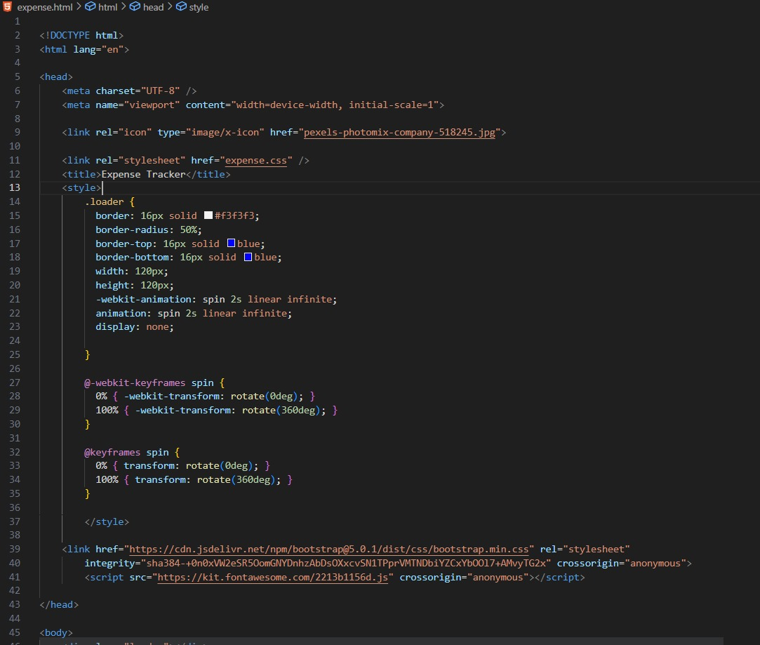

**Fig 4.2 HTML (Main Site)**



**Fig 4.3CSS (Main Site)**

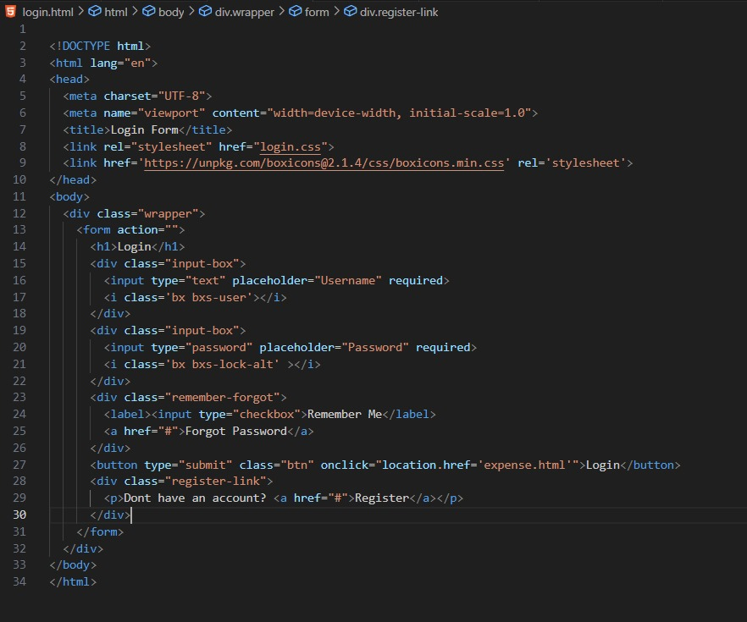

**Fig 4.4 HTML (Login Page)**

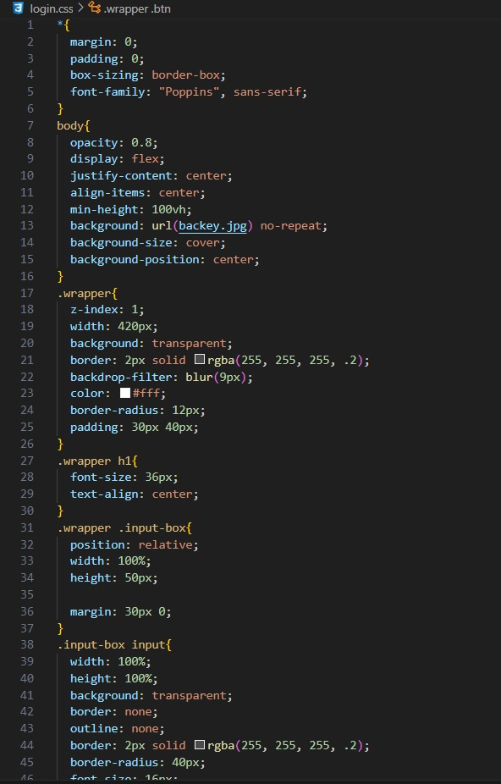

**Fig 4.5 CSS(Login Page)**

**Chapter 5: Results and Evaluation**

5.1. Implementation Progress and Achievements:

1. Overview of Milestones:

The development of the Expense Tracker application progressed through several key milestones, marking significant progress in the implementation of core features and functionalities. These milestones typically included:

Initial Planning and Research: Conducting preliminary research, gathering user requirements, and outlining the project scope and objectives.

i. UI/UX Design: This crucial phase involves meticulously crafting the user interface (UI) and user experience (UX) to ensure effortless navigation, aesthetic appeal, and seamless interaction. By focusing on intuitive design principles and visual aesthetics, this process aims to create an engaging and user-friendly interface that enhances overall usability and satisfaction.

ii. Backend Development: The backbone of the Expense Tracker application, backend development encompasses the creation of robust infrastructure, database schemas, and server-side logic. This facilitates essential functionalities such as expense tracking, budgeting, and reporting, ensuring data integrity, scalability, and efficient performance to support the application's core features effectively.

iii. Frontend Development: Frontend development focuses on building the user-facing components of the application, including UI elements, interactive features, and client-side logic. This phase aims to deliver a seamless and responsive user experience across various devices and screen sizes, enabling users to interact intuitively with the application's features and functionalities.

iv. Integration and Testing: Integration involves incorporating third-party APIs for data synchronization and conducting comprehensive testing and validation procedures to identify and rectify any bugs or issues. This iterative process ensures that the

application meets stringent quality standards and operates reliably across different environments and usage scenarios.

v. Deployment: Deployment involves the rollout of the application on multiple platforms, including web and mobile, to broaden its accessibility and reach. This phase ensures that the Expense Tracker application is readily available to users across diverse devices and operating systems, maximizing its utility and impact.

vi. User Feedback and Iteration: User feedback plays a pivotal role in refining and optimizing the application's design and functionality. Through usability testing, beta testing, and user surveys, valuable insights are gathered to inform iterative improvements that align with user preferences and expectations, enhancing overall user satisfaction and engagement.

vii. Milestone Achievements: Each milestone represents a significant advancement in the development journey, marking key accomplishments and progress towards the completion and launch of the Expense Tracker application. These milestones signify critical junctures where development efforts converge to bring the application closer to fruition, ultimately culminating in its readiness for public release.

1. Key Accomplishments:

Throughout the implementation process, several key accomplishments were achieved, demonstrating progress and success in various areas:

i. Integration with External APIs: The successful integration with external APIs from financial institutions or service providers marks a pivotal achievement for the Expense Tracker application. This integration facilitates real-time updates of financial data, including transaction records and account balances, enhancing the application's utility and providing users with accurate and up-to-date information to make informed financial decisions.

ii. Multi-Platform Deployment: The deployment of the Expense Tracker application across multiple platforms, such as web browsers, iOS, and Android devices, represents a significant milestone in expanding its accessibility and reach. By catering to diverse user preferences and

device capabilities, this multi-platform deployment strategy ensures that the application can effectively serve a broader audience, maximizing its impact and usability.

iii. User Authentication and Data Security: The implementation of robust user authentication mechanisms, such as OAuth or JWT, underscores the application's commitment to data security and user privacy. These authentication protocols safeguard user accounts and sensitive financial data, mitigating the risk of unauthorized access or manipulation. By prioritizing data security, the Expense Tracker application instills user trust and confidence, enhancing its credibility and value proposition.

iv. Demonstrating Technical Capabilities and Reliability: These accomplishments serve as tangible evidence of the Expense Tracker application's technical prowess, reliability, and usability. By showcasing its ability to seamlessly integrate with external APIs, deploy across multiple platforms, and prioritize data security, the application solidifies its value proposition and fosters user satisfaction. These achievements reinforce the application's position as a trusted and indispensable tool for effective financial management.

1. Challenges and Strategies:

Despite the achievements, the implementation process of the Expense Tracker application encountered various challenges and obstacles, which required innovative strategies and solutions to overcome:

i. Compatibility Issues: The Expense Tracker application encountered challenges with compatibility across various devices, operating systems, and web browsers, impacting user experience and performance. Addressing these issues required comprehensive testing and optimization efforts to ensure seamless functionality and accessibility across diverse platforms, ultimately enhancing overall usability and user satisfaction.

ii. Data Synchronization Complexities: Complexities in data synchronization processes posed significant hurdles, including conflict resolution, ensuring data consistency, and optimizing synchronization efficiency. Overcoming these challenges necessitated meticulous attention to detail and the implementation of robust synchronization algorithms and protocols, ensuring accurate and efficient data updates across different devices and environments.

iii. User Interface Design Iterations: Iterating on the user interface design based on user feedback and usability testing results was integral to enhancing the Expense Tracker application's usability and visual appeal. This iterative process involved refining interface elements, improving visual clarity, and addressing usability issues to create a more intuitive and user-friendly experience. By prioritizing user feedback and incorporating iterative design improvements, the application evolved to better meet user needs and preferences, ultimately enhancing overall user satisfaction and engagement.

5.2. Technical Evaluation:

I. Performance and Scalability: Extensive testing was conducted on the Expense Tracker application to assess its performance across diverse usage scenarios. The findings revealed satisfactory performance levels and scalability, indicating the application's ability to effectively manage increased user loads and accommodate growing data volumes without compromising functionality or responsiveness.

II. Adherence to Standards: The application underwent thorough evaluation against established coding standards, security best practices, and industry benchmarks for web and mobile applications. By adhering to these standards, the application demonstrated robustness, security, and maintainability, instilling confidence in its reliability and compliance with industry norms.

III. Iterative Improvements: Continuous iterations and enhancements were implemented based on testing outcomes, user feedback, and performance benchmarks. These refinements encompassed optimizing user interface responsiveness, enhancing data synchronization mechanisms, and refining budget forecasting algorithms. By

prioritizing iterative improvements, the application evolved to deliver an enhanced user experience, improved functionality, and greater overall efficiency.

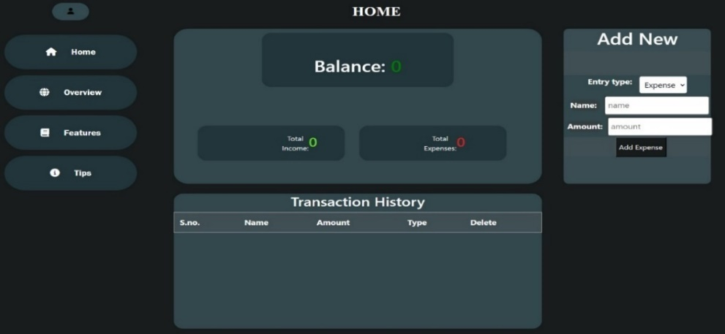5.3. Iterative Improvements:

* 1. (Web Home Page)

I. The iterative improvement process entailed ongoing cycles of testing, collecting feedback, and refining to continually enhance the user experience and effectiveness of the application. This iterative approach ensured that the application consistently evolved to meet user needs and expectations, fostering greater satisfaction and usability over time.

II. Specific changes encompassed a range of enhancements aimed at improving various aspects of the application. These included refining the user interface to enhance usability, implementing performance optimizations to reduce loading times, and addressing bugs identified during testing and user feedback sessions. By systematically addressing these areas for improvement, the application was able to deliver a smoother, more efficient, and more enjoyable user experience.

5.4. Evaluation of Project Outcomes:

I. Overall Success: The Expense Tracker project accomplished its objectives by delivering a user-friendly tool for effective financial management. Through meticulous development and user-centric design, the application successfully met user needs, enhancing the overall financial management experience.

II. Impact on Users: Evaluation of project outcomes revealed significant positive impacts on users' financial practices. Users reported heightened awareness of their spending habits, improved adherence to budgeting goals, and enhanced financial literacy, underscoring the application's efficacy in facilitating better financial management practices.

III. Challenges and Lessons Learned: Despite encountering challenges such as platform compatibility issues and data synchronization complexities, the project provided invaluable learning opportunities. Key lessons include the importance of prioritizing user-centered design, conducting regular testing, and embracing agile development methodologies. These insights serve as guiding principles for future software projects, ensuring a more streamlined and successful development process.

5.5. Future Directions and Recommendations:

* 1. Future Enhancements:

Suggestions for future enhancements aim to enrich the user experience and functionality of the Expense Tracker application. These may include:

i. Expense Categorization Enhancement: Enhancing expense categorization functionalities by incorporating advanced features that empower users to meticulously classify expenses into specific categories such as groceries, transportation, and entertainment. This augmentation aims to facilitate better organization and analysis of financial data, enabling users to gain deeper insights into their spending patterns and effectively manage their budgets.

ii. Goal Setting and Tracking Innovation: Introducing innovative goal-setting functionalities within the Expense Tracker application, empowering users to define and track their financial objectives. By enabling users to set goals such as saving for a vacation or paying off debt, the application fosters a proactive approach to financial management, allowing users to monitor their progress and stay motivated towards achieving their aspirations.

iii. Social Sharing Integration: Integrating social sharing capabilities into the Expense Tracker application to facilitate community engagement and accountability. This feature allows users to share their financial achievements, budgeting tips, and insights with friends or peers, fostering a collaborative environment where users can support and motivate each other towards their financial goals. By encouraging social interaction, the application cultivates a sense of camaraderie and accountability among users, enriching the overall user experience and promoting financial well-being.

These enhancements would add value to the Expense Tracker application, making it more comprehensive, engaging, and tailored to the evolving needs of users.

1. Maintenance and Support:

Recommendations for maintenance and support focus on ensuring the long-term sustainability and reliability of the Expense Tracker application. This may involve:

* 1. Establishing a Support System: Setting up a dedicated support system, such as a helpdesk or knowledge base, to assist users with troubleshooting, inquiries, and technical assistance.
  2. Regular Updates and Bug Fixes: Committing to regular updates and bug fixes to address any issues, improve performance, and introduce new features based on user feedback and technological advancements.
  3. User Training and Resources: Providing user training materials, tutorials, and resources to help users maximize the benefits of the Expense Tracker application and navigate its features effectively.

By prioritizing maintenance and support efforts, the Expense Tracker application can maintain user satisfaction, minimize downtime, and adapt to changing user needs and technological landscapes.

5.6. Conclusion:

The project has successfully achieved its objectives of developing and evaluating an advanced expense tracker application, with promising results and implications for future research and development in the field of financial technology



Fig 5.3(Welcome Page)



Fig 5.4 (Login Page)

**Chapter 6: Conclusion**

6.1. Summary of Project Objectives:

* 1. Recap of Objectives:

At the onset of the project, the primary objective was to address the need for an effective expense tracking solution tailored specifically for college students. This objective stemmed from recognizing the unique financial challenges faced by college students, including limited income, varying expenses, and the need for financial literacy. By developing an Expense Tracker application, the aim was to empower college students to manage their finances more effectively, make informed spending decisions, and cultivate responsible financial habits. The overarching objectives included:

1. Simplifying Expense Tracking: Providing college students with a user-friendly platform to track their expenses conveniently and accurately, whether manually or through automated imports from bank accounts and credit cards.
2. Promoting Financial Awareness: Equipping users with insights into their spending habits and patterns through detailed reports, visualizations, and recommendations, thereby fostering financial awareness and informed decision-making.
3. Facilitating Budget Management: Assisting users in setting personalized budgets for different expense categories and offering alerts and notifications to help them stay within their budgetary limits.
4. Encouraging Goal Setting: Enabling users to set financial goals, track their progress, and receive reminders to stay focused and motivated towards achieving their objectives.
5. Enhancing Financial Literacy: Promoting financial literacy among college students by providing educational resources, tips, and tools within the application to help them develop essential money management skills.
   1. Summary of Key Features and Functionalities:

The Expense Tracker application is designed to meet the aforementioned objectives through its comprehensive set of features and functionalities, which include:

1. Expense Tracking: Users can effortlessly record and categorize their expenses, leveraging manual input or automated imports from their bank accounts and credit cards.
2. Financial Insights: The application provides users with detailed reports, visualizations, and recommendations to analyze their spending habits, identify trends, and make informed financial decisions.
3. Budget Management: Users can set personalized budgets for various expense categories and receive alerts and notifications to help them monitor their spending and stay within their budgetary limits.
4. Goal Setting and Tracking: The application enables users to establish financial goals, track their progress over time, and receive reminders to stay on track towards achieving their objectives.
5. Financial Literacy Resources: Users have access to educational materials, tips, and tools within the application to enhance their financial literacy, develop money management skills, and make sound financial choices.

6.2. Recap of Project Process:

1. Overview: The project journey involved meticulous planning, agile development methodologies, and the use of appropriate tools and techniques to bring the Expense Tracker application to fruition.
2. Methodologies and Tools: Agile development methodologies were employed, alongside tools such as version control systems, project management platforms, and continuous integration pipelines.
3. Milestones and Challenges: Significant milestones were achieved throughout the project, albeit with challenges such as platform compatibility issues, data synchronization complexities, and user interface design iterations

6.3. Evaluation of Project Outcomes:

1. Success Assessment: The Expense Tracker application was evaluated positively in achieving its objectives, evidenced by its impact on users' financial management practices and behaviours.
2. Impact Reflection: The application contributed to improved financial literacy, empowered users to make informed financial decisions, and facilitated better budget adherence among college students.
3. Challenges and Strategies: While challenges were encountered, strategies such as agile adaptation, user feedback incorporation, and iterative improvements were instrumental in overcoming them.

6.4. Contributions to Personal Finance Management:

1. Significance:

The Expense Tracker project holds significant importance as it addresses common challenges encountered by users in managing their finances effectively. Specifically tailored for college students, the Expense Tracker application provides a streamlined solution to meet their unique needs and circumstances. College students often face various financial challenges, including limited income, fluctuating expenses, and the need to balance academic and personal life. By offering a dedicated platform for expense tracking and budget management, the Expense Tracker project aims to alleviate these challenges and empower users to take control of their finances.

The significance of the Expense Tracker project lies in its ability to provide college students with a practical tool that simplifies the often daunting task of financial management. By offering intuitive features and user-friendly interfaces, the application enables users to track their expenses, set budgets, and monitor their financial progress with ease. This not only helps users stay organized and informed about their spending habits but also promotes a sense of financial responsibility and accountability.

Furthermore, by addressing these challenges head-on, the Expense Tracker project contributes to the overall financial well-being and stability of college students. By instilling good financial habits and providing valuable resources for financial literacy, the application sets users on a path towards long-term financial success.

1. Benefits:

The Expense Tracker application offers a range of benefits to its users, promoting financial awareness, responsibility, and empowerment:

1. Financial Awareness: By providing users with insights into their spending habits and patterns, the application enhances financial awareness. Users gain a better understanding of where their money is going, enabling them to make informed decisions about their finances.
2. Financial Responsibility: Through features such as budget setting and expense tracking, the application encourages users to take ownership of their financial decisions. By setting budgets and monitoring their spending, users develop a greater sense of financial responsibility and accountability.
3. Financial Empowerment: The Expense Tracker application empowers users to take control of their finances and work towards their financial goals. Whether it's saving for tuition, managing student loans, or building an emergency fund, the application provides tools and resources to help users achieve their objectives.
4. Simplified Budgeting: With intuitive features that simplify budgeting, the application makes it easier for users to manage their finances. Users can set personalized budgets for different expense categories and receive alerts and notifications to help them stay on track.

6.5. Lessons Learned and Recommendations:

1. Insights Gained: Valuable insights were gained from the project experience, including successes, failures, and areas for improvement.
2. Recommendations: Future projects or iterations of the Expense Tracker application could benefit from enhanced user engagement strategies, expanded feature sets, and improved data synchronization mechanisms.

6.6. Conclusion:

The Expense Tracker project has admirably fulfilled the need for a user-friendly and efficient tool for personal finance management, particularly catering to the requirements of college students. With its multifaceted functionalities, intuitive design, and seamless integration across various devices and platforms, the application offers users a comprehensive suite of tools to monitor expenses, scrutinize spending patterns, and make well-informed financial decisions with ease. By fostering financial awareness and accountability, the Expense Tracker emerges as an indispensable asset in empowering individuals to navigate their financial landscapes confidently, thereby laying the groundwork for a financially secure future filled with promise and opportunity.

**References**

1. Albrecht, D. W., & Skoglund, M. B. (2017). *HTML and CSS: Design and Build Websites.* John Wiley & Sons.
2. Duckett, J. (2014). *JavaScript and JQuery: Interactive Front-End Web Development.* John Wiley & Sons.
3. W3C. (n.d.). HTML Living Standard. Retrieved from https://html.spec.whatwg.org/multipage/
4. Mozilla Developer Network (MDN). (n.d.). CSS Reference. Retrieved from <https://developer.mozilla.org/en-US/docs/Web/CSS/Reference>
5. Flanagan, D. (2011). *JavaScript: The Definitive Guide.* O'Reilly Media.
6. MDN Web Docs. (n.d.). JavaScript Reference. Retrieved from <https://developer.mozilla.org/en-US/docs/Web/JavaScript/Reference>
7. Chaffey, D., & Ellis-Chadwick, F. (2019). *Digital Marketing: Strategy, Implementation, and Practice.* Pearson UK.
8. Nielsen, J., & Budiu, R. (2013). *Mobile Usability.* New Riders.
9. Crockford, D. (2008). *JavaScript: The Good Parts.* O'Reilly Media.
10. Gamble, S. (2019). *SQL QuickStart Guide: The Simplified Beginner's Guide to Managing, Analyzing, and Manipulating Data with SQL.* ClydeBank Media LLC.
11. MongoDb Documentation. (n.d.). MongoDB Manual. Retrieved from <https://docs.mongodb.com/manual/>
12. Friedman, B., Hurley, D., Howe, D. C., & Nardi, B. A. (2017). *Software Studies: A Lexicon.* MIT Press.
13. Fazzari, A. L., & Shocks, M. B. (2018). *After Piketty: The Agenda for Economics and Inequality.* Oxford University Press.
14. Git Documentation. (n.d.). Git Handbook. Retrieved from <https://git-scm.com/doc>
15. Google Developers. (n.d.). Lighthouse. Retrieved from <https://developers.google.com/web/tools/lighthouse>
16. Patel, A. (2020). *Learn SQL Database Programming.* Independently Published.
17. Amazon Web Services (AWS). (n.d.). AWS Documentation. Retrieved from <https://docs.aws.amazon.com/>
18. Microsoft Azure Documentation. (n.d.). Azure Documentation. Retrieved from <https://docs.microsoft.com/en-us/azure/>
19. Google Cloud Documentation. (n.d.). Google Cloud Documentation. Retrieved from <https://cloud.google.com/docs>